Ozone Layer Depletion

Introduction: Ozone layer is a necessary component for our atmosphere. Its depletion is considered as a thinning of the Ozone layer in the earth’s atmosphere. Because it can prevent us from sun’s harmful UV rays. If this layer does not work, we will get skin cancer, eye contact problem etc. On the other hand, many other plants and animals will be affected for this.
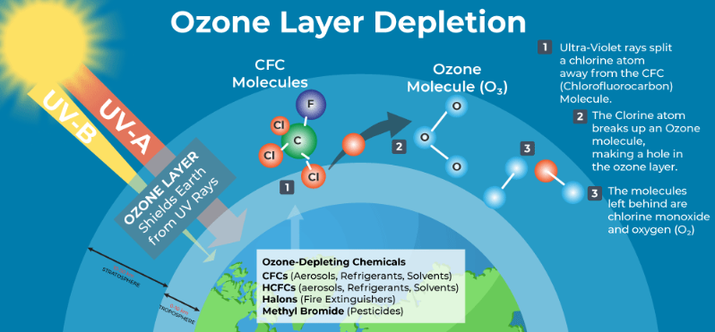
click here to see the image source
In 2024, Ozone layer remains a major concern because of dangerous chemical such as CFC. The ozone layer is recovering us at a slow pace instead of efforts to minimize our usage of these chemicals. So, it can be said that we have to protect it for our planet’s health.

Causes:
The main cause of ozone layer depletion is excessive uses of man-made substances into the atmosphere. CFC are commonly employed in refrigeration, air conditioning and aerosol spray propellants.
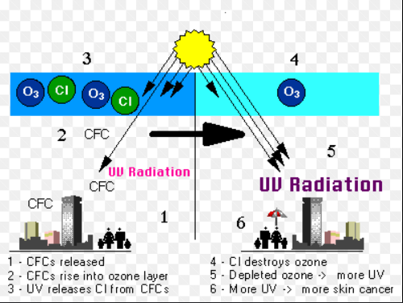
Click here to see the image source

The process of chemical equations of occurring ozone depletion is given below
- Breakdown of CFCs:

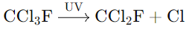

- Reaction with Ozone:

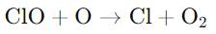

Here we can see, a chlorine atom reacts with an Ozone molecule where chlorine monoxide and oxygen are products. After that chlorine monoxide reacts with an oxygen atom, releasing the chlorine atom to destroy more Ozone.
Statistical data:
Historical:

In 1970s | concerns about CFCs and ozone depletion arise.
In 1980s | significant reduction of ozone layer and the discovery of the Antarctic ozone hole observed.
In 1987s | Montreal Protocol was signed to phase out CFCs and other ozone-depleting substances.
In 1990s-2000s | gradual stabilization and recovery of the ozone layer continued monitoring.

Consequences:
Here are some consequences of Ozone Layer Depletion
- Environmental damage:
  - excessive uses of UV radiation can harm the plants, the crop fields and the animals and birds of the environment.
  - damage the ocean food chain and can damage the food process chain. Cohn (1987), mentioned that the excessive using of CFC gas was the main cause of damaging food chain.

- The Physical health problems for humans:
  - UV radiation causes skin cancer for human beings.
  - damages our eye contact problem, critical thinking and psychology issues.
  - hampers our body immune system and growth rate.

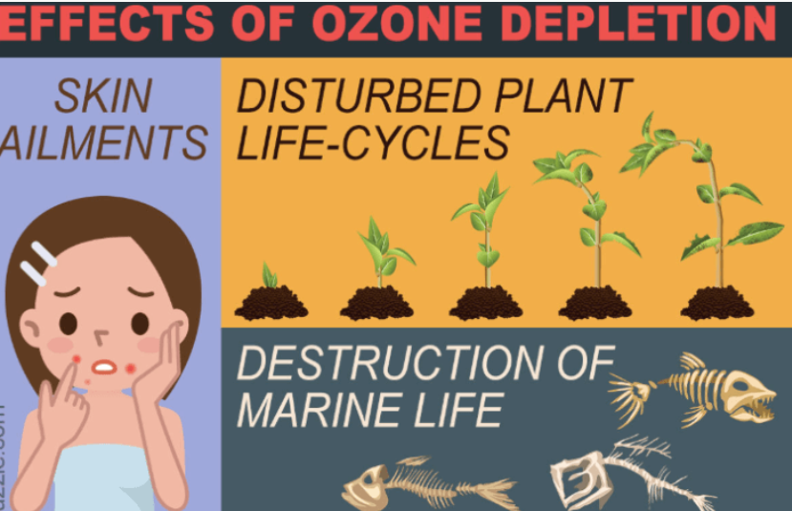
Click here to see the image source

- It’s bad effect for the ecosystem:
- destroys our biodiversity rate, development of species.
- destroys our wildlife, fish and amphibians.
- can impact the entire ecosystem, altering habitats and sources for many animals.

Remedies:
Here are some efforts to prevent Further Ozone Layer Depletion
- International Agreements:

- Montreal Protocol (1987): This is the major global agreement to reduce the excessive use of ozone depleting chemicals. We can give example about CFCs. On the other hand, all countries have designated signs for this convention. This event can give a great impact for the environment.

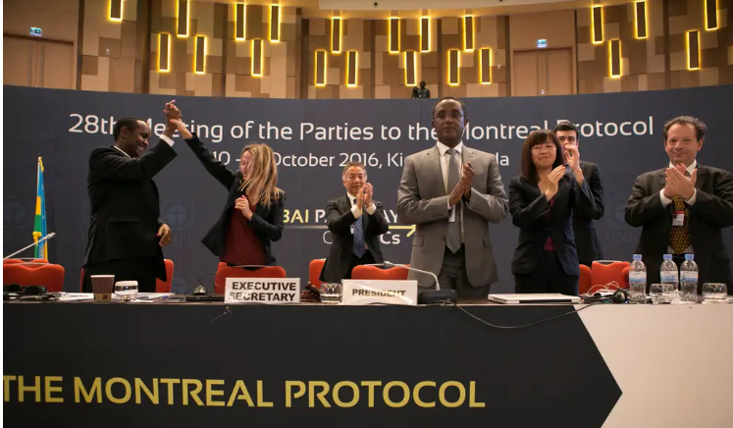

Click here to see the image source

- Amendments to the Montreal Protocol: The amendments to the agreement are to reinforce it over time by targeting other compounds, such as HFCs which are called greenhouse gases but do not directly impair the ozone layer.

- National Policies:

- Many countries have started banning the CFC production and other harmful chemicals.
- Government is trying to promote the alternative ozone-friendly products and substances.

- Research and Monitoring:

- NASA and United Nations Environment Programmers are continuously monitoring the update condition of ozone layer.
- Environmental safer products are ongoing to save the ozone layer.

Future Actions to protect the Ozone layer:
- Encourage industries to make safe technologies and environmental products.
- Reducing the excessive uses of greenhouse gas emission can help to prevent the climate change.
- Using crops and forestry can help to maintain the ecological balance and reduce ozone depletion.
- Public and private organizations can play a vital role in this field. Cook (1990), mentioned that globalization will be the best decision to protect the Ozone layer.
.
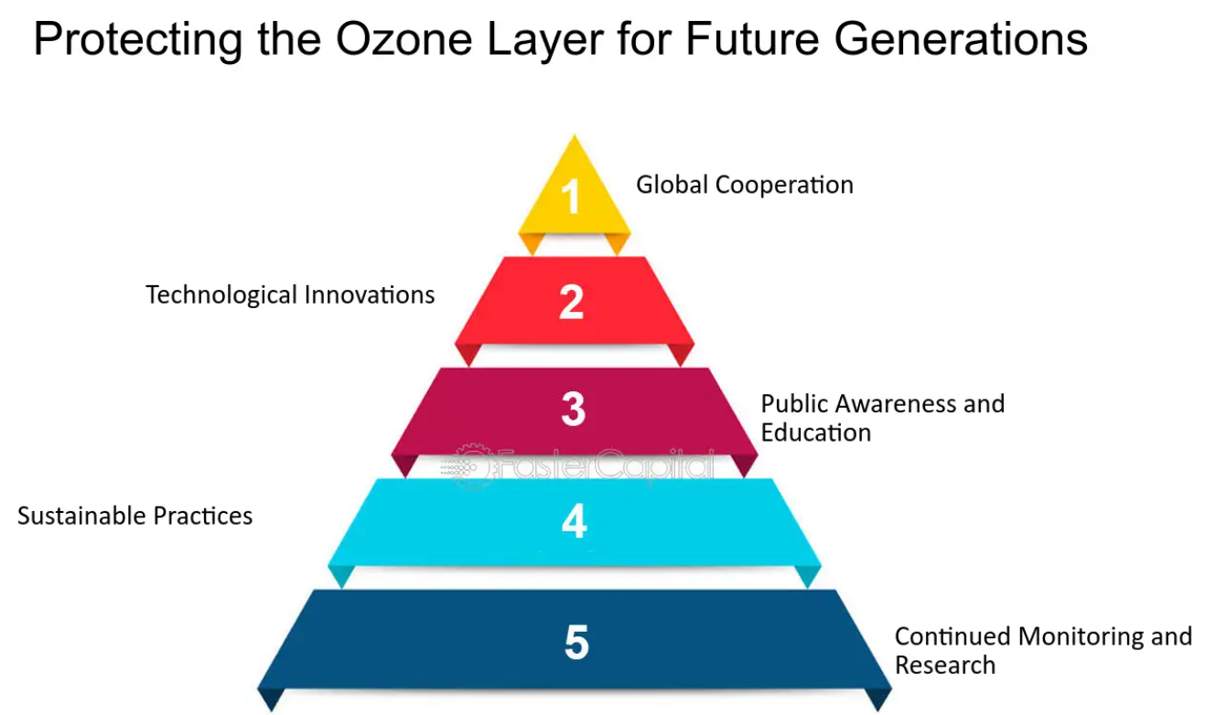
Click here to see the image source

Conclusion: As we know that Ozone layer plays a significant role model for our ecological imbalance. But this layer is being damaged day by day for our unethical activities and that is why people are suffering so much. We are fighting against strong diseases but yet we are not preventing environment. So, it is high time we prevented our environment as soon as possible. We must keep working together to protect the ozone layer.

References:
- Cohn, J. P. (1987). Chlorofluorocarbons and the Ozone Layer. Bio Science, 37(9), 647-650. https://www.jstor.org/stable/1310709

- Cook, E. (1990). Global Environmental Advocacy: Citizen Activism in Protecting the Ozone Layer. Ambio, 19(6/7), 334-338. https://www.jstor.org/stable/4313729

